Coding Challenge – Packaging Domain
Task 1: Defect Rate per Product
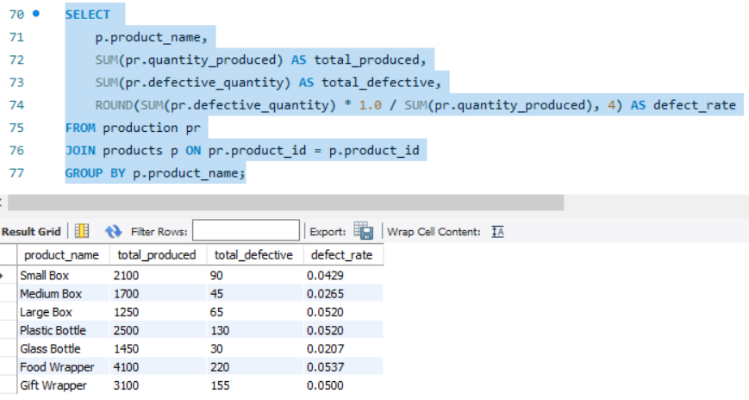
Task 2: Top Performing Product (Revenue)
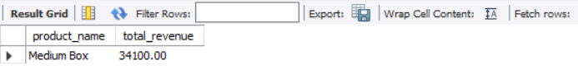
Task 3: Monthly Production Trend
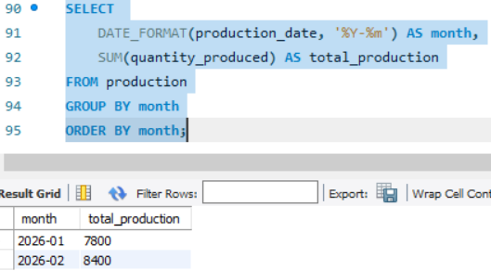
Task 4: Category-wise
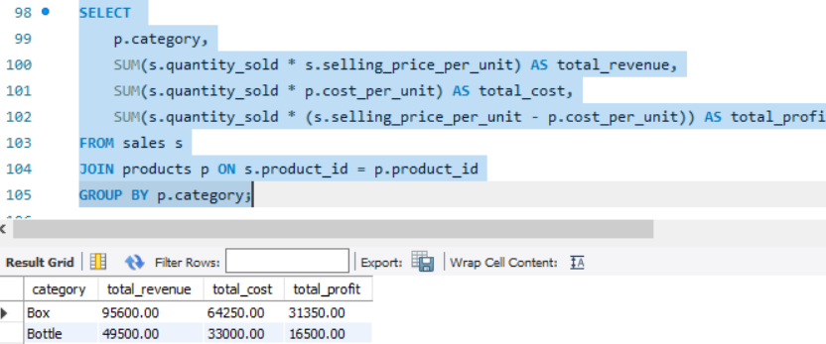

Task 5: Identify High Defect Days
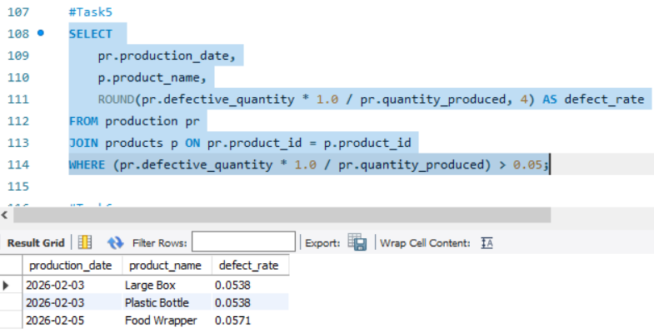
Task 6: Running Total Revenue
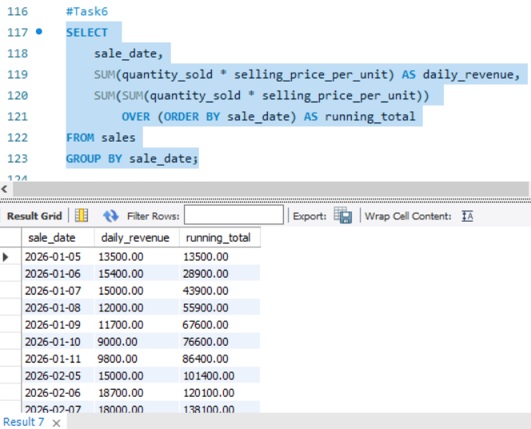
Task 7: Best Category by Profit Margin
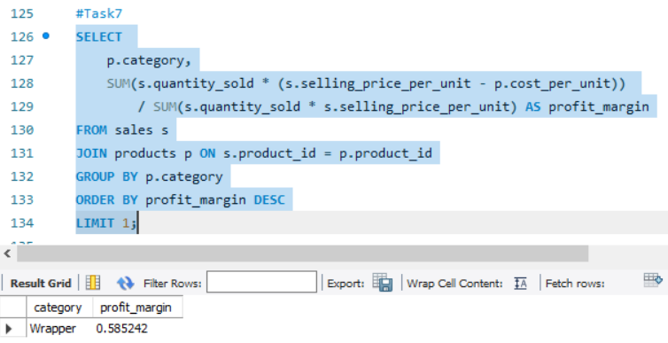

Task 8: Unsold Inventory
